**ACCESSIBILITY AND ACCEPTABILITY EVALUATION OF VIMONET E-CLINIC WEBSITE**

**BY**

**MERCY AKINTOLA**

**2017/1/66010CT**

**DEPARTMENT OF COMPUTER SCIENCE**

**FEDERAL UNIVERSITY OF TECHNOLOGY**

**MINNA**

**DECEMBER, 2023**

**ACCESSIBILITY AND ACCEPTABILITY EVALUATION OF VIMONET E-CLINIC WEBSITE**

**BY**

**MERCY AKINTOLA**

**2017/1/66010CT**

**PROJECT SUBMITTED TO THE DEPARTMENT OF COMPUTER SCIENCE, SCHOOL OF INFORMATION AND COMMUNICATION TECHNOLOGY, FEDERAL UNIVERSITY OF TECHNOLOGY, MINNA, NIGERIA IN PARTIAL FULFIILMENT OF THE REQUIREMENT FOR THE AWARD OF THE DEGREE OF BACHELOR OF TECHNOLOGY IN COMPUTER SCIENCE**

**DEECEMBER, 2023**

**DECLARATION**

I hereby declare that this project titled: **“Accessibility and Acceptability Evaluation of Vimonet E-Clinic Website”** is a collection of my research work written by me under the supervision of Dr. S.A Adepoju and it has not been presented for any other qualification anywhere. Information from other sources (published or unpublished) has been duly acknowledged and referenced.

AKINTOLA, Mercy

2017/1/66010CT Signature and Date

Federal University of Technology,  
 Minna, Nigeria.

**CERTIFICATION**

This project tiled **“Accessibility and Acceptability Evaluation of Vimonet E-Clinic Website”** by AKINTOLA Mercy (20171/66010CT) meets the regulations governing the award of Bachelor of Technology (B.Tech) in Computer Science of the Federal University of Technology, Minna, Nigeria.

Dr. S.A Adepoju

Project Supervisor Signature and Date

Dr. (Mrs.) O.A Abisoye

Head of Department Signature and Date

External Supervisor Signature and Date

DEDICATION

To Almighty God, whose divine grace, wisdom and unlimited love has been my guiding light.

To my beloved parents, the pillars of my existence, whose unwavering support and unconditional love have helped me through my academic journey.

With gratitude and love, I humbly dedicate this work as a token of appreciation for the blessings of faith and family that have enriched my writing and my soul.

ACKNOWLEDGEMENTS

It is a delight to acknowledge the significant contributions of several individuals who have been instrumental in making this project a reality.

To God who has made this journey a one of a tremendous and amazing process for me.

To my dad and mum, who their unwavering support has been a major backbone for me, I sincerely appreciate all your cares, prayers and love you have shown towards me.

With deepest appreciation to my siblings, for their prayers, love and steadfast support.

To my project supervisor, Dr. S.A Adepoju, I sincerely express my gratitude for your guidance, commitment to my academic growth and your constructive feedback who has helped me throughout the phase of this project.

My amazing HOD, Dr. Mrs Abisoye, whose motherly advice and her strength has been a strong pillar of success in this journey.

I sincerely appreciate all my loving lecturers, Dr. Ojerinde, Dr. Bashir, Dr. Enesi but to mention a few whose teachings has left a positive and a lasting impact in my academic journey.

To Prof. M.A. Ojo, I sincerely appreciate your fatherly role and support that you played throughout my academic journey in Minna.

Special thanks to Manasseh for his selfless act during the course of my project act, who went an extra mile to support me with his expertise at pressing moment.

I also recognize the support of my campus fellowship, whose services both physically and spiritual infused a unique value into the progress of my project work. And to my Bestie Josh, whose support has been one of a special kind since our paths crossed. To my amazing friends, mentors and colleagues, whose readiness to extend a helping hand and support both academically, financially, morally contributed immensely to the success of this project and my academic journey. I want to say a big thank you.

In essence, I am fortunate to be surrounded by such an incredible support system. Each one of you has played a vital role in shaping the outcome, and I want you to know how deeply I appreciate your involvement. Thank you for being an integral part of this journey and I look forward to celebrating more collective achievements. God bless you abundantly. I love you all.

ABSTRACT

The aim of this project work is to carry out accessibility and acceptability testing of VIMONET E-clinic website. The study employs a multi-faceted approach, utilizing five distinct online automated tools which are: WAVE, Achecker, TAW, GTmetrix and Lighthouse to assess the website's performance in terms of meeting accessibility standards and user acceptability. The results from Lighthouse tool shows performance as 43%, Accessibility as 75%, Best practices as 100%, SEO as 91%, TAW categorized the problems into four attributes which are: perceivable, operable, understandable, robust. A survey was carried out using online questionnaire where sixty participants took the survey and gave feedback about the platform. The results show that the VIMONET e-clinic website is generally user-friendly and easy to navigate. Based on the identified issues, it is recommended that all form elements have and descriptive labels to enhances accessibility, improve the alt text for images throughout the website and ensure the buttons have accessible, discernible names and ensuring it aligns with best practices in web development and accessibility standards.

TABLE OF CONTENTS

Cover Page

Title Page ii

Declaration iii

Certification iv

Dedication v

Acknowledgements vi

Abstract vii

Table of Contents viii

List of Tables xii

List of Figures xiv

CHAPTER ONE: INTRODUCTION

1.1 Background to the Study 1

1.2 Motivation of the Study 2

1.3 Statement of Problem 3

1.4 Aim and Objectives of the Study 3

1.5 Scope and Limitation of Study 4

1.6 Significance of Study 4

CHAPTER TWO: LITERATURE REVIEW

2.1 Overview of Telemedicine platform 6

2.2 Historical Evolution of Telemedicine 7

2.3 Accessibility Testing of Telemedicine Platforms7

2.3.1Accessibility Testing Methodologies8

2.3.2 Accessibility Guidelines and Standards 8

2.4 Acceptability Testing of Telemedicine Platforms 9

2.4.1 Diverse Approaches to Acceptability Testing 9

2.5 The Impact of Accessibility and Acceptability Testing 9

2.6 Challenges in Accessibility and Acceptability Testing 10

* 1. Strategies to Improve Accessibility and Acceptability Testing 11

2.8 Differences between Web Accessibility and Web Acceptability 12

2.9 Benefits of Telemedicine 14

2.10 Telemedicine in Specialized Fields 15

2.11 Future Prospects 16

2.12 Related Works 16

CHAPTER THREE: MATERIALS AND METHODS

3.1 Introduction 20

3.2 Analysis of VIMONET E-clinic Website 20

3.3 Site Evaluation 20

3.4 Methodology  21

3.5 Online Automated Evaluation Tools 21

3.5.1 WAVE (Web Accessibility Evaluation Tool) 22

3.5.2 AChecker 23

3.5.3 Lighthouse 24

3.5.4 TAW (Test Accessible Web) 25

3.5.5 GTmetrix 26

3.6 Questionnaire Based Method 26

CHAPTER FOUR: RESULTS AND DISCUSSION

4.1 Introduction 28

4.2 Automated Tool Based Results 28

4.2.1 WAVE Results 28

4.2.2 Achecker Results 29

4.2.3 Lighthouse Results 30

4.2.4 TAW Results 32

4.2.5 GTmetrixs 33

4.2.6 Comparative analysis of Online automated Evaluation Tools 33

CHAPTER FIVE: SUMMARY, CONCLUSION AND RECOMMENDATION

5.1 Introduction 37

5.2 Summary 37

5.3 Conclusion 37

5.4 Recommendation 38

REFERENCES 39

APPENDICES

LIST OF TABLES

TABLE PAGES

2.1: Differences between web accessibility and web acceptability 13

4.2: Results of WAVE for VIMONET E-clinic website 28

4.2: Results of Lighthouse for VIMONET E-clinic website 30

4.3: Results of TAW for VIMONET E-clinic website 32

4.4: Results of GTmetrix for VIMONET E-clinic website 33

4.5: Comparative Analysis of Website Evaluation Tools. 35

LIST OF FIGURES

FIGURES PAGE

Fig 3.1: WAVE Homepage 23

Fig 3.2: Achecker Homepage 24

Fig 3.3: Lighthouse Homepage 25

Fig 3.4: TAW Homepage 26

Fig 3.5: GTmetrix Homepage 27

**CHAPTER ONE**

**INTRODUCTION**

* 1. **Background to the Study**

Over recent years, a profound transformation has taken place in the medical field, catalysed by the progress in telecommunication tech and an increasing need for convenient and reachable health services. As a counter to these issues, telemedicine has appeared as a viable alternative. Telemedicine platforms, such as the VIMONET E-clinic developed by the Federal University of Technology Minna, offer a diverse array of features to grant patients access to quality healthcare services, irrespective of their geographical location or physical constraints.

Telemedicine platforms interchangeably termed as Electronic-clinic (E-clinic) is defined as the ability for medical professionals to diagnose and treat patients remotely. *Haleem et al., (2021)*

Key features of this platform are as follows; real-time remote consultations between healthcare practitioners and patients, centralized electronic medical database system, efficient appointment scheduling/management, electronically streamline the process of issuing and managing medication prescriptions and remote health monitoring via tracking.

The key aspects and benefits associated with e-clinic platform, are as follows; quick access and easy convenience in connecting with healthcare providers remotely, saves time and cost efficient by eliminating travel need whilst reducing wait times, expansion of medical services scope alongside with increased number of accessible healthcare providers, secured data management of patient privacy, easy tracking system of patient’s health progress and consistent care continuity of patient.

Crucially, accessibility and acceptability testing serve as keystones in ensuring that telemedicine platforms are not only accessible to all users but are also acceptable and user-friendly. While obstacles are faced head on, the rising acceptance levels of these platforms will demonstrate their potential to revolutionize healthcare and improve patient outcomes. In conclusion, E-clinic platforms should not replace traditional face-to-face clinical sessions but should complement it. Certain medical illness or emergencies undoubtedly seek active physical inspections whereby certain procedures can only be conducted when present physically. Nonetheless, in less critical scenarios, concerning minor consultations, no emergency check-ups, then e-clinics platform can offer such services. *P. B. Angood, (2001)*

* 1. **Motivation of the Study**

Conducting accessibility and acceptability testing on VIMONET E-clinic website holds intrigue and meritorious exploration due to their capability of fostering an inclusive, user-friendly and regulated healthcare environment. This evaluation aids in alleviating strain during crises or emergencies thrust upon hospitals while also ensuring ongoing patient care continuity. When these platforms are evaluated thoroughly, it enables making informed decisions easy, which enhance the quality of care, paving way towards innovation brimming with opportunities in the healthcare industry, which are embraced and valued by users worldwide. In essence, this makes evaluation worth delving into E-clinic platform both beneficially valuable and engrossingly fascinating.

* 1. **Statement of Problem**

It is crucial to gauge the accessibility, acceptability and potentiality of e-clinic platforms in optimizing healthcare services. Evaluating their role as a bridge for improved access to healthcare while maximizing resources utilization need to be in consideration. Furthermore, this evaluation should also be an examination of how patients interact with these systems, taking into considerations regulations in order to identify area available for future innovation and advancements that will ensure seamless integration within the wider medical industry.

* 1. **Aim and Objectives of the Study**

This project aims to perform a thorough evaluation of the accessibility and acceptability testing of the VIMONET E-clinic platform. The key objectives include the following:

1. To identify the tools used for accessibility evaluation.
2. To conduct accessibility evaluation of the VIMONET E-clinic platform.
3. To conduct acceptability testing of the VIMONET E-clinic platform.
4. To provide detailed recommendations for improving the accessibility and acceptability of the VIMONET E-clinic platform.
   1. **Scope and Limitation of the Study**

This project focuses on the web-based version of the VIMONET E-clinic platform, encompassing all aspects of the platform's design, functionality, and user experience. The study will involve a combination of quantitative and qualitative data collection methods, including:

1. Accessibility Evaluation: Utilizing automated accessibility testing tools and manual testing techniques to identify and assess accessibility issues.
2. User Surveys: Administering surveys to a broader range of users to gather quantitative data on user satisfaction, perceived usefulness, and overall acceptability.

This project work is restrained to the accessibility and acceptability evaluation excluding other areas such as usability issues, data security.

**1.6 Significance of the Study**

The findings of this project will have significant implications for the development and improvement of the VIMONET E-clinic platform. By identifying accessibility and acceptability issues, the research will inform the development of enhancements that make the platform more inclusive and user-friendly for all users. Additionally, the research findings will contribute to the growing body of knowledge on accessibility and acceptability testing of telemedicine platforms, providing valuable guidance for other developers and researchers working in this field. Overall, this research aims to address the critical need for comprehensive accessibility and acceptability testing of telemedicine platforms, ensuring that these platforms are inclusive, user-friendly, and accessible to all individuals, regardless of their abilities or backgrounds.

**CHAPTER TWO**

**LITERATURE REVIEW**

The rapid growth of telemedicine platforms has revolutionized the healthcare landscape, offering convenient and accessible healthcare services to individuals worldwide. However, ensuring that these platforms are inclusive and user-friendly for all individuals’ demands meticulous attention to accessibility and acceptability testing.

**2.1 Overview of Telemedicine platform**

Telemedicine, or E-clinic as it's often denoted, is the application of using telecommunications technology to deliver health services from a distance and it has acquired tremendous focus and incorporation in modern times. *Alenoghena et al., (2023)*. This literature review aims to provide a comprehensive exploration of telemedicine, probing into its accessibility and acceptability testing, tracing its historical evolution, significant technological milestones, benefits, challenges, and future prospects. By synthesizing existing research, this review aims to contribute to a comprehensive understanding of the field and its potential impact on healthcare delivery.*(Bashshur et al., 2000; Chau et al., 2002)*

**2.2 Historical Evolution of Telemedicine**

Telemedicine, a term coined in the 1970s by Thomas Bird, literally translates as “healing at a distance” — from Latin “medicus” and Greek “tele.” Its roots trace back to the early 20th century, where telegraph and telephone systems paved the way for early experiments transmitting medical information, such as ECG data, over telegraph wires. Pioneers like Sir William Osler and Dr. Albert Abrams explored telecommunication's potential in medicine, though limited by the technology of the time. *Mun & Turner, (1999)*

The evolution continued with the emergence of radiotelegraphy in the 1920s, as Dr. Edward G. Martin pioneered the use of radio waves for remote medical consultations. World War II marked a significant turning point, utilising telemedicine for remote consultations and diagnosis of soldiers' injuries, highlighting its potential for emergency medicine. *Craig & Patterson, (2017)* Closed-circuit television (CCTV) found application in psychiatric evaluations during this period.

NASA's investment in telemedicine during the 1960s-1970s, prompted by the space race, extended its reach to remote communities through projects like STARPAHC, addressing healthcare disparities. The integration of videoconferencing technology in the 1980s-1990s, exemplified by projects like NASA Spacebridge to Russia, further expanded telemedicine's capabilities. Advances in telecommunications, including the internet, played a pivotal role. *Sosa-Iudicissa et al., (1998)*

The 21st century witnessed a proliferation of telemedicine applications, driven by digital health technologies such as mobile devices, high-speed internet, electronic health records (EHRs), and telehealth platforms. The COVID-19 pandemic accelerated telemedicine adoption, demonstrating its efficacy in maintaining healthcare services while minimizing virus transmission.

Ongoing technological advancements in the 2020s integrate artificial intelligence (AI), wearable devices, and remote patient monitoring systems into telehealth platforms, enhancing diagnostic accuracy and patient care. Regulatory changes facilitating cross-state practice and improving reimbursement policies further contribute to telemedicine's evolution. *Lukas et al., (2020)*

**2.3 Accessibility Testing of Telemedicine Platforms**

The importance of conducting comprehensive accessibility testing on telemedicine platforms cannot be overstated. Ensuring that these platforms are accessible to individuals with disabilities is not only a matter of inclusivity but also a fundamental requirement for delivering equitable healthcare services *(Al-Qirim, 2009; Chellaiyan et al., 2020)*. Accessibility testing involves the meticulous identification and rectification of potential barriers that could impede the navigation, comprehension, and interaction capabilities of users with disabilities *Chellaiyan et al., (2020)*.

**2.3.1 Accessibility Testing Methodologies**

Accessibility testing methodologies are diverse, catering to different aspects of platform evaluation. Automated testing tools, as advocated by Hollander and Carr (2018), offer a swift and efficient means of pinpointing potential accessibility issues. Simultaneously, manual testing techniques, in line with the approach outlined by DeLone and McLean (2016), delve deeper into the user experience, providing a nuanced assessment of the platform's accessibility for individuals with disabilities.

Moreover, integrating user testing with representatives from various disability groups becomes imperative. As suggested by *Hoa et al. (2017)*, this qualitative approach allows for the collection of valuable feedback, unveiling potential usability barriers that might impede the accessibility of the telemedicine platform. By combining automated tools, manual assessments, and real-world user feedback, a comprehensive accessibility testing strategy can be formulated to ensure the inclusivity of telemedicine services.

**2.3.2 Accessibility Guidelines and Standards**

A cornerstone of effective accessibility testing is the adherence to established guidelines and standards. Notably, the Web Content Accessibility Guidelines (WCAG) 2.1 and Section 508 of the Rehabilitation Act provide a robust framework for developing telemedicine platforms that cater to a diverse range of disabilities *Loane & Wootton, (2002)*. These guidelines address key facets of accessibility, ensuring that web content is not only perceivable and operable but also understandable and robust in its design *Loane & Wootton, (2002)*.

**2.4 Acceptability Testing of Telemedicine Platforms**

Beyond the scope of accessibility, acceptability testing emerges as a critical phase in evaluating telemedicine platforms. This multifaceted testing paradigm, as outlined by Lo et al. (2013), extends its focus to overall usability, user satisfaction, and perceived usefulness. It encapsulates a broad spectrum of factors influencing user acceptance, including ease of use, navigation, functionality, overall user experience, and the perceived value that the platform brings to its users *Lo et al., (2013)*.

**2.4.1 Diverse Approaches to Acceptability Testing**

In telemedicine platform development, several methodologies are utilised for acceptability testing, offering nuanced perspectives on user experiences *Stefan et al., (2018)*. User surveys provide quantitative insights into user satisfaction, perceived usefulness, and overall acceptability, offering a numerical lens on user perceptions *Venkatesh et al., (2003)*. Complementing this, usability testing sessions provide an opportunity for direct observation of user interactions, pinpointing specific areas for refinement in platform functionality and design *Mehralian et al., (2019)*. To delve into the qualitative realm, user interviews yield in-depth insights into user experiences, preferences, and potential pain points, enriching the understanding of user perspectives *Hennemann et al., (2018).*

**2.5 The Impact of Accessibility and Acceptability Testing**

Acceptability testing ensures user-centric design, quality assurance, enhanced user satisfaction, continuous improvement, and reduced risk. The feedback collected serves as a foundation for ongoing product enhancement and innovation. *Roca & McCarthy, (2019)*

The widespread influence of accessibility and acceptability testing in telemedicine platform development cannot be overemphasised *Hollander & Carr, (2018)*. By addressing accessibility challenges and enhancing overall acceptability, these platforms overcome demographic boundaries, providing equitable healthcare access to a diverse user community. This results not only in aiming for heightened user satisfaction but consistently achieving it across all user interactions with the telemedicine platform *Lo et al., (2013)*.

**2.6 Challenges in Accessibility and Acceptability Testing for Telemedicine Platforms**

The journey through telemedicine platform development unveils a host of challenges in accessibility and acceptability testing. These challenges, encompassing both telemedicine and web platforms, present formidable obstacles for developers:

1. Lack of Standardisation: The absence of standardised methods and evaluation criteria in telemedicine introduces variations in testing approaches, hindering the comparison of results across diverse contexts (Hoa et al., 2017; Mehralian et al., 2019).
2. Resource Constraints: The intersection of cost considerations and time commitments poses a substantial challenge, especially for telemedicine developers working within budgetary constraints (Hennemann et al., 2018; Venkatesh et al., 2003).
3. User Engagement Gap: Limited user involvement in the testing process results in a disparity between the envisioned design and the actual preferences and needs of users (Mehralian et al., 2019; Stefan et al., 2018).
4. Diverse User Base: Websites catering to a diverse user base with varying needs, preferences, and cultural backgrounds face challenges in creating a test group that accurately represents this diversity. Diseases (2013)
5. Changing User Expectations: The dynamic nature of user expectations regarding web acceptability, evolving with technological advancements and design trends, presents an ongoing challenge. Bashshur et al., (2000)
6. Accessibility Compliance: Ensuring web accessibility and compliance with standards like WCAG presents a challenge, with the imperative to meet the needs of users with disabilities integral to acceptability.(Loane & Wootton, 2002; Vasquez-Cevallos et al., 2018)
7. Multiple Devices and Browsers: The challenge of ensuring websites are accessible and acceptable across various devices and browsers necessitates meticulous testing for cross-browser and cross-device compatibility.(Puentes et al., 2007)
8. Data Privacy and Security: Addressing heightened user concerns about data privacy and security poses a challenge, requiring websites to be both acceptable and trustworthy from a security perspective. Miller, (2003)
9. Performance Optimization: Balancing high-performance requirements with rich content to ensure optimal loading poses a challenge in the pursuit of web acceptability. Haleem et al., (2021)
10. Acceptance of New Technologies: The acceptability of emerging technologies, such as AI chatbots or voice interfaces, may vary among users, making testing for acceptability of cutting-edge features challenging. Goel et al., (2017)

**2.7 Strategies to Improve Accessibility and Acceptability Testing**

To overcome these challenges and cultivate a more inclusive telemedicine environment, consider the following overarching recommendations:

1. Standardised Methodologies: Establishing clear guidelines and standards fosters cohesion and comparability in testing practices, addressing issues related to the lack of standardisation. Hoa et al., (2017).
2. Accessible Training Initiatives: Providing accessible training on testing methodologies empowers developers and testers, easing concerns related to limited expertise (DeLone & McLean, 2016; Hollander & Carr, 2018).
3. Continuous User Engagement: Encouraging sustained user participation throughout the development phases ensures that the telemedicine platform aligns with the authentic needs and preferences of its diverse user base (Mehralian et al., 2019; Stefan et al., 2018).
4. Regular Accessibility Audits: Perform regular accessibility audits to ensure compliance with standards like WCAG, promoting inclusivity in web design.
5. Security Assessments: Regularly assess and communicate the security measures in place to build trust and enhance the acceptability of the website. Patel et al., (2020)

**2.8 Differences between Web Accessibility and Web Acceptability**

Acceptability testing and accessibility testing are essential methods for evaluating the quality and effectiveness of products or services, focusing on different aspects and goals.

Table 2.1: Differences between Web Accessibility and Web Acceptability

|  |  |  |
| --- | --- | --- |
| Aspect | Web Accessibility | Web Acceptability |
| Goal | Guarantees the provision of identical opportunities and access for individuals with disabilities to engage with online content. | Concentrates on pleasing the users, catering to their likes, and the total acceptability of an online site or web-based application. |
| Criteria | It necessitates objective standards like alternate textual descriptions for images, keyboard-friendly features, suitable color differentials, and correct semantic formation. | It incorporates subjective personal taste elements like visual appeal, configuration, simplicity in utilization, and general user contentment. |
| Tools and Testing | Focuses on online automated checks to identify potential issues related to compliance and accessibility standards. | Entails user testing, questionnaires, and subjective evaluations. |
|  |  |  |
| Guidelines | It is governed by standards such as the Web Content Accessibility Guidelines (WCAGs), | Often includes superior practices in user experience (UX) design, usability testing, and user interface (UI) design without precise regulatory standards. |
|  |  |  |
| Target Audience | It primarily caters to individuals who have disabilities, like those with vision, hearing, physical, and cognitive challenges. | It encompasses a wider audience, with an emphasis on user satisfaction and preferences. |
|  |  |  |

**2.9 Benefits of Telemedicine**

1. Telemedicine enables patients to receive medical attention at the convenience of both doctor and him, and at the same time, he is safe. This may imply that a person does not need to take time off from work or arrange childcare. *Goel et al., (2017)*
2. Telemedicine prevents the possibility of contracting an infection at the hospital especially for people who have chronic medical problems or a weakened immune system. *Bunnell et al., (2020)*
3. Telemedicine service providers could have lower overhead rates. Clinicians may find that telemedicine supplementing their income by allowing them to take care of more patients. The patient may be happy with their physician if they do not have to fly to the office or wait for treatment or get infected from the hospital *.Everard et al., (2022)*
4. Improved Access to Healthcare: Telemedicine eliminates geographical barriers, making healthcare services more accessible to rural and underserved populations.
5. Cost-Efficiency: Telemedicine reduces travel expenses for patients and can lower healthcare costs through remote monitoring and early intervention. *Shinoda et al., (2022a)*
6. Enhanced Continuity of Care: Patients can receive follow-up care and monitoring without the need for frequent in-person visits.
7. Timely Consultations: Telemedicine enables faster consultations, reducing waiting times for patients. *Wilson et al., (2015)*

**2.10 Telemedicine in Specialized Fields**

1. Telepsychiatry: Telemedicine has been particularly effective in providing mental health services, addressing the shortage of mental health professionals in many regions.*Sageena et al., (2021)*
2. Teledermatology: Dermatologists can diagnose and treat skin conditions through telemedicine, reducing wait times for dermatology appointments.(Fouad et al., 2023)
3. Teleoncology: Remote consultations for cancer patients help in treatment planning and reducing the burden of travel during chemotherapy and radiation therapy.(P. Angood et al., 2001)

**2.11 Future Prospects**

1. Integration of AI: AI-driven tools for diagnosis, treatment recommendations, and remote monitoring are expected to play a larger role in telemedicine.(Sageena et al., 2021)
2. Expansion of Telemedicine Services: Telemedicine is likely to expand to cover a broader range of medical specialties and services.(Lukas et al., 2020)
3. Policy and Regulation Updates: Governments are likely to adapt regulations to promote telemedicine while addressing privacy and reimbursement concerns.
4. Patient Empowerment: Increasing patient engagement through telemedicine platforms will empower individuals to take a more active role in their healthcare.(Biancuzzi et al., 2023; Kyriacou et al., 2003)

In conclusion, E-clinic systems has made significant strides in improving healthcare accessibility and delivery. Despite challenges, its continued growth and integration into mainstream healthcare services are expected. As technology continues to evolve and regulations adapt, e-clinic role in shaping the future of healthcare is likely to become even more pronounced, with the potential to enhance patient outcomes and reduce healthcare disparities.(Lo et al., 2013; Shinoda et al., 2022b)

**2.12 Related Works**

Mbunge et al., (2022) carried out a methodical review of existing literature to amalgamate findings on telemedicine in sub-Saharan Africa. The research highlighted challenges include lack of policy and political drive toward virtual care, sustaining costs of virtual healthcare services, technological and infrastructural hindrances, and cultural hurdles. Suggestions on how to circumvent some of these barriers, includes creating resilient policies and formulas for virtual healthcare, integrating virtual care into medical academic programs, promoting research and development in virtual care, amplifying health financing, and establishing virtual health solutions that cater to the uniqueness of African health systems.

Adetunji et al., (2021) acknowledged the application of telemedicine as a viable tech solution that can help protect patients, health professionals and also lessen patient movement, thereby reducing virus transmission. Hence, this research aims to present detailed data regarding the use of eHealth, mHealth, and telemedicine as a proactive step to enhance clinical care. Detailed accounts on the practical execution of eHealth, mHealth, and telemedicine during the COVID-19 pandemic handling are also included.

Bisu et al., (2018) suggests plausible telemedicine application settings with a designed framework aiming at improving the reach of quality healthcare through satellite and combined satellite-terrestrial systems (ISTNs). Telemedicine employs telecommunications and IT to amplify healthcare services to neglected, remote communities. The extensive reach, broadcasting/multicasting capacity, and high bandwidth of satellites located in the Geostationary Earth Orbit (GEO) have the potential to be leveraged as an instrument for broadening quality healthcare to underprivileged rural areas that are hard to reach.

Bunnell et al., (2020) carried out a survey inspecting the traits of telemental health professionals and analyses how the acceptability of telemedicine specifics impacts their aspiration to exploit this service more frequently. Between March and May 2019, telemental health professionals (N = 177) participated in an online survey. The majority of the professionals (75%) utilized telemedicine for less than 25% of their office hours, yet 70% revealed an aspiration to escalate its use in the future. It was found that the perception of telemedicine offering a wider patient reach, better work-life equilibrium, versatility in care delivery, and being a part of innovative care significantly determined professionals plans to employ it more.

Haleem et al., (2021) looks deeper into the key capabilities, the integration with treatment processes, and the hazards in adopting telemedicine in healthcare. Seventeen vital uses of telemedicine in healthcare are identified in this paper. Telemedicine allows both patients and physicians to track the treatment process. Nevertheless, this innovation only supplements in-person consultation and is no complete replacement for it. Today, this technology is a preferred choice for individuals who are unable to visit the doctor or are confined to their homes, particularly during a health crisis.

Alenoghena et al., (2023) This research indicates that one approach to addressing the pandemic is by maximizing the use of telemedicine as a means for remote healthcare. The study takes a detailed look at the diverse telecommunication technologies presently suggested, their standards and the challenges they face. Essentially, a broad overview of advancements in telemedicine technology, standards, and protocols is provided, while also highlighting several unresolved matters for researchers. Noteworthy areas of specialist application are specifically mentioned. The survey concludes by highlighting significant research challenges and potential future trajectories in relation to telemedicine technology.

Bokolo Anthony Jnr, (2020) carried out research, encompassing 35 research studies which were published from 2019 up until May 2020. These studies were utilized to offer both theoretical and practical proof regarding the impact of deploying virtual healthcare and telemedicine for remote patient care during the COVID-19 pandemic, also offering practical advice on utilizing telemedicine and virtual care during the current pandemic. Moreover, this research provides insights into the potential for integrating virtual care solutions in the foreseeable future, and thereby, including digital technologies within the healthcare industry.

Jauregui-Velarde et al., (2023) designed a prototype mobile telemedicine application - an Android-based solution for mental health services. The result was an efficiently designed telemedicine mobile app prototype enhancing the connection between patients and specialists towards easing the provision of mental health services. Evaluation of the prototype's quality was conducted via consultation with expert opinion, assessing efficiency, usability, and security dimensions of the application.

Chau et al., (2002) scrutinized the acceptance of telemedicine technology by physicians. Utilizing a theory comparison method, it appraised the degree to which dominant intention-based models, including the technology acceptance model (TAM), the theory of planned behavior (TPB), and an integrated model, can elucidate individual physicians' decisions to accept technology. From more than 400 physicians' feedback, both models were assessed in relation to overall fit, predictive capacity, and their causal associations.

**CHAPTER THREE**

**RESEARCH METHODOLOGY**

**3.1 Introduction**

The VIMONET E-Clinic platform stands as a key resource for delivering health services in this current digital age. To make sure it continues to serve effectively, an extensive assessment has been carried out, covering both its accessibility and acceptability features.

**3.2 Analysis of VIMONET E-clinic Website**

The VIMONET E-Clinic portal, accessible at (https://vimonet.health), underwent a thorough evaluation to assess its performance, end-user interaction, security, and overall efficiency. The primary objective of this website is to deliver health services virtually. The site possesses a visually appealing user interface, imagery, and English is predominantly utilized in its textual content. User registration is necessitated to avail health services via this platform.

**3.3 Site Evaluation**

In web design, a paramount factor to consider is accessibility, ensuring that the website can be effectively utilized by all users, irrespective of their abilities or impairments. The assessment targeted the compliance to accessibility protocols and guidelines. The primary objective of performing the accessibility and acceptability evaluation for the VIMONET E-Clinic platform is to verify that the platform upholds the utmost standards of user inclusivity and satisfaction such as:

1. Text Alternatives for Non-Text Content
2. Keyboard Accessibility
3. Colour and Contrast
4. Form and Input Validation
5. User Experience (UX) Considerations
6. Performance Metrics
7. Ensure Inclusive User Experience
8. Comply with Standards and Guidelines
9. Enhance Trust and Credibility
10. Empower a Diverse User Base

**3.4 Methodology**

The evaluation followed a structured methodology by using two major methods, which are:

1. Online automated evaluation tools
2. Questionnaire based method

**3.5 Online Automated Evaluation Tools**

An online automated website evaluation tool is a software application or service that automatically scrutinizes and appraises several characteristics of a website's performance, functionalities, and other key attributes. These tools are designed to simplify the website's evaluation process, providing invaluable observations and feasible suggestions without needing manual meddling. The major objectives of utilizing online automated website evaluation tools encompass improving user experience, optimizing performance, guaranteeing accessibility, and boosting the website's total efficacy.

**3.5.1 WAVE (Web Accessibility Evaluation Tool)**

WAVE, an acronym denoting Web Accessibility Evaluation Tool, comprises a collection of resources formulated to aid proprietors, developers, and designers of websites in examining and improving the accessibility levels of their web content. Developed by WebAIM (Web Accessibility in Mind), are used to scrutinize web pages for alignment with established accessibility standards and guidelines, thereby guaranteeing a usable website experience for persons with diverse disabilities.

WAVE serves as an invaluable tool to foster web accessibility, adhering to the principle of inclusion and offering directions to guarantee that digital content is within reach of all users' abilities. It plays a part in building a more balanced online experience, cultivating a web space that is welcoming and user-friendly for all.

Users can access WAVE via a browser extension, a web-based tool, or by incorporating it into their existing development workflow. By entering the URL of a web page or using the browser extension, WAVE generates a visual display on the webpage, emphasizing components and offering feedback through symbols and color differentiation. Simultaneously, the tool gives a thorough analysis, pointing out accessibility difficulties, and suggesting strategies for enhancement.

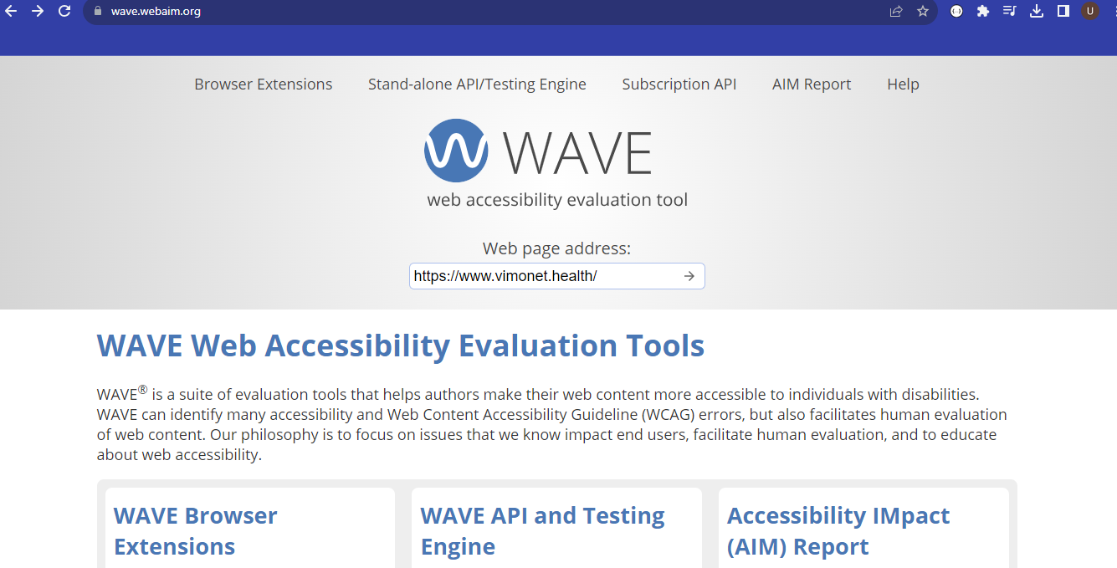

Fig 3.1: WAVE Homepage

**3.5.2 AChecker**

AChecker, often known as Accessibility Checker, is an open-source online tool designed specifically for evaluating and promoting the accessibility of web content to assess and enhance the accessibility of web content. Similar to other web accessibility evaluation tools, AChecker's objective is to assist web developers, designers, and content creators in pinpointing and resolving accessibility issues on their sites. This involves fostering an online environment that is more inclusive, user-friendly for individuals with disabilities, and expanding its reach to a more diverse audience.

Through the web interface or integration into development surroundings, AChecker is easily accessible to users. By providing a web page URL or uploading an HTML document, users can initiate an accessibility assessment. AChecker proceeds to examine the content, pinpoints problems and offers a detailed report filled with practical suggestions.

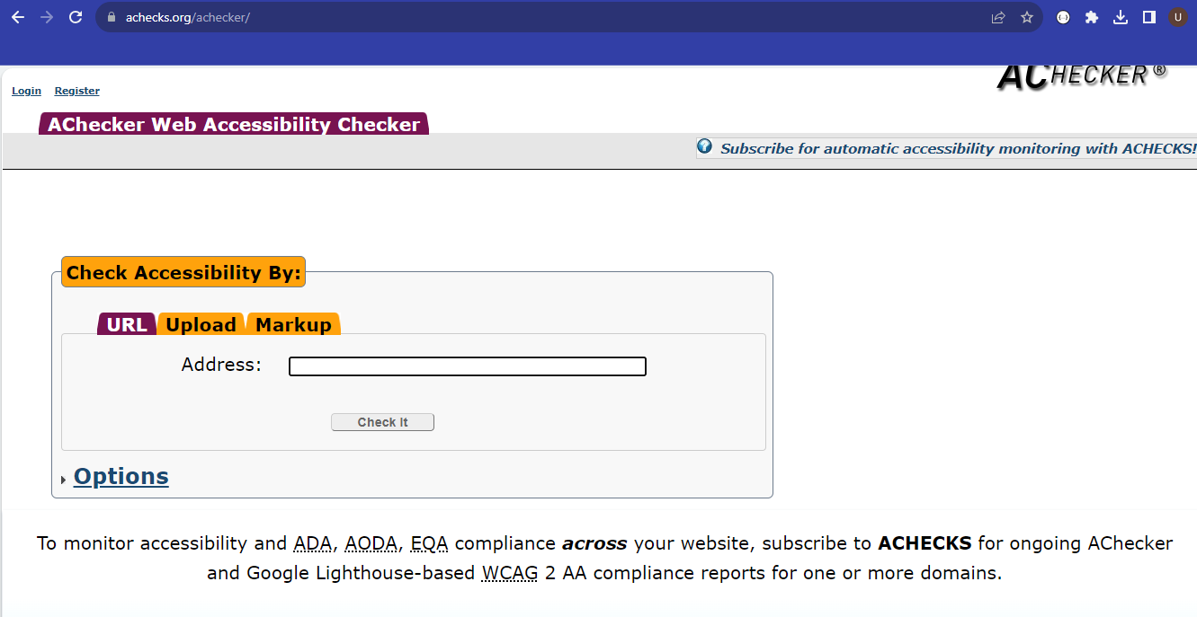

Fig 3.2: Achecker Homepage

**3.5.3 Lighthouse**

Lighthouse is an open-source, automated tool geared towards the enhancement of web page quality. Developed by Google, Lighthouse has gained extensive usage from developers, webmasters, and website proprietors, aiding in the assessment and optimization of their websites' performance, disability access, SEO, and all-inclusive best practices. Lighthouse proffers practical insights and suggestions to enhance user engagement, streamline web content, and ensure accessibility. The thorough audits it offers prove to be an invaluable resource in the continuous endeavour to create quick, user-friendly, and easily navigable web experiences.

Lighthouse can used in various ways:

1. Browser Extension: Lighthouse offers an extension available for Google Chrome and other web browsers. Detailed audit reports can be generated directly from user's browsers.
2. Command Line Interface (CLI): This provides easy integration of Lighthouse into building procedures and automation flow.
3. Web Interface: Google provides a web-based version of Lighthouse (https://developers.google.com/web/tools/lighthouse), enabling users to assess web pages remotely.

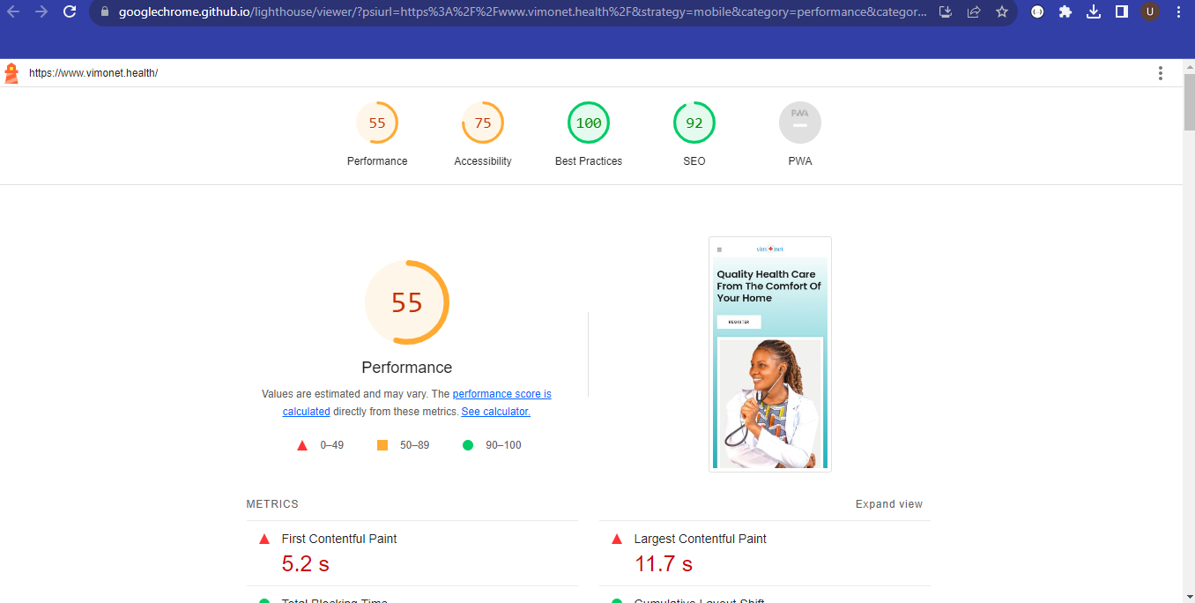

Fig 3.3: Lighthouse Homepage

**3.5.4 TAW (Test Accessible Web)**

TAW, an acronym for Test Accessibility with WAVE is an online tool for measuring a website's accessibility elements. It seamlessly incorporates the features of the Web Accessibility Evaluation Tool (WAVE) to scrutinize websites, ensuring they align with accessibility standards and guidelines. It integrates with the WAVE (Web Accessibility Evaluation Tool) to check websites for compliance with accessibility standards and guidelines.

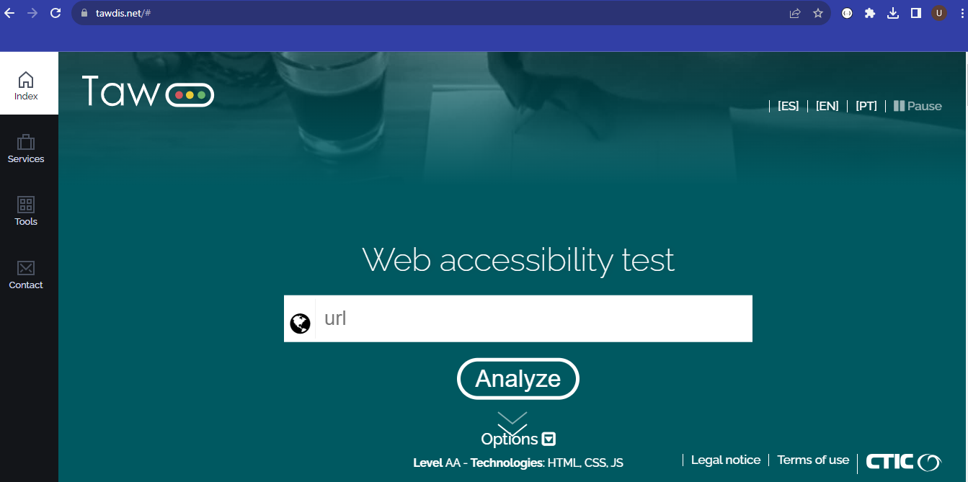

Fig 3.4: TAW Homepage

**3.5.5 GTmetrix**

GTmetrix functions as a digital assessment device aiming at gauging the efficiency and the load speed of websites. It offers insights and recommendations to support website owners, developers, and designers in refining their websites for enhanced speed while loading as well as enhanced user experience.

By inserting the URL a user want to scrutinize, GTmetrix executes numerous examinations, assessing the website's effectiveness using diverse measurements. A comprehensive report encompassing scores, recommendations, and visualizations.

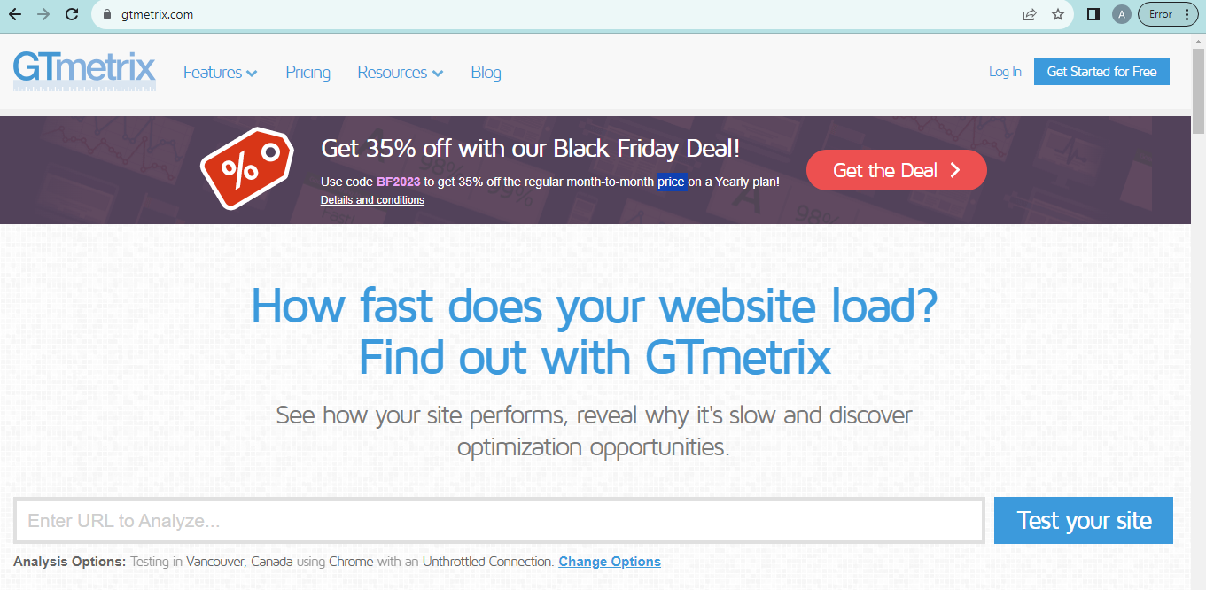

Fig 3.5: GTmetrix Homepage

**3.6 Questionnaire Based Method**

A questionnaire is a research tool or instrument often utilized in research to garner responses from individuals through a sequence of inquiries. It can be in a structured, semi-structured, or unstructured format, and find widespread use in diverse sectors for things like research, assessments, or surveys. In this context, it is used to gather feedback on the user-friendliness of the website to diverse user groups. The questionnaire used in this project work can be found in appendix A.

**CHAPTER FOUR**

**RESULTS AND DISCUSSION**

**4.1 Introduction**

This chapter entails the details of the analysis of the online automated tools and the questionnaire-based method that was conducted during the research.

**4.2 Automated Tool Based Results**

This research work used five online automated tools to check the accessibility of VIMONET E-clinic platform. The results generated from each tool are given below.

**4.2.1 WAVE Results**

This evaluation tools detected the Errors, Alerts, Features, Contrast Errors and Structural elements. The issues are explained further:

**Errors:**

1. Missing Label: A form does not have a corresponding label.
2. Empty button: A button is empty or has no value text.
3. Empty link: A link contains no text.

**Features**

1. Alt text: Image alternative text is present.
2. Linked image with alt text: Alternative text is present for an image that is within a link.
3. Language: The language of the document or a page element is identified.

**Alert**

1. Suspicious alt text: Alternative text is likely insufficient or contains extraneous information.
2. Same alt text: A nearby image has the same alternative text.
3. Skipped heading level: A heading level is skipped.
4. Suspicious link text: Link text contains extraneous text or may not make sense out of context.
5. Redundant link: Adjacent links go to the same URL

**Contrast**

1. Very low contrast: Very low contrast between text and background grounds.

**Structural Elements**

1. Heading level1: A first heading (<h1> element) is present.
2. Heading level2: A second heading (<h2> element) is present.
3. Heading level3: A third heading (<h3> element) is present.
4. Heading level4: A fourth heading (<h4> element) is present.
5. Heading level5: A fifth heading (<h5> element) is present.
6. Unordered list: An unordered (bulleted) list (<ul> element) is present.
7. Header: A <header> element or banner landmark is present.
8. Navigation: A <nav> element or navigation landmark is present.
9. Footer: A <footer> element or content information landmark is present.

Table 4.1: Results of WAVE for VIMONET E-clinic website

|  |  |  |  |  |  |
| --- | --- | --- | --- | --- | --- |
|  | **Errors** | **Alerts** | **Features** | **Structural Elements** | **Contrast Errors** |
| Missing form label  – 2 | Suspicious alt text- 2 | Alt text – 1 | Heading level 1 – 1 |  |
| Empty button  -3 | Same alt text  – 3 | Linked image with alt text– 1 | Heading level 2 – 4 |  |
| Empty link  -3 | Skipped heading level – 3 | Language – 1 | Heading level 4  – 13 |  |
|  | Suspicious link text – 1 |  | Heading level 5  – 5 |  |
|  | Redundant link - 1 |  | Unordered list – 6 |  |
|  |  |  | Header – 1 |  |
|  |  |  | Navigation – 1 |  |
|  |  |  | Footer – 1 |  |
| **Total** | **8** | **10** | **3** | **32** | **16** |

**4.2.2 Achecker Results**

This evaluation tools categorized the problems into known problems, likely problems and potential problems.

Known problem - 33

Likely problem - 0

Potential problem - 156

The known problem was detected to be:

1. Label text is empty.
2. (italic) element used.
3. Input element, type of “text”, missing an associated label.
4. Input element, type of “text”, has no text in label.
5. Header nesting – header following h1 is incorrect.
6. Anchor contains no text.

The potential problems are:

1. ‘title’ might not describe the document.
2. Visual lists may not be properly marked.
3. Site missing site-map.
4. Image may contain text that is not in Alt text.
5. Words or phrases that are not in the document’s primary language may not be identified.
6. Tab order may not follow logical order.
7. Form may delete information without allowing for recovery.
8. Form submission error messages may not identify empty.
9. All required ‘form’ fields may not identify empty.
10. Alt text does not convey the same information as the image.
11. Group of links with a related purpose are nit marked.
12. Text may refer to items by shape, size, or relative position alone.

To resolve these issues, the following criteria are to be followed:

1. Add text to the input element’s associated label that describes the purpose or function of the control.
2. Add a label element that surrounds the control’s label.
3. Replace i (italic) elements with em (emphasis) or strong
4. Add text to the ‘a’ element or the title attribute of the ‘a’ element.
5. Modify the header levels so only an h1 or h2 follows h1.
6. Add text to the label element.

**4.2.3 Lighthouse Results**

This evaluation tools categorized the problems into performance, accessibility, best practices, and SEO. The results are:

Table 4.2: Results of Lighthouse for VIMONET E-clinic website

|  |  |
| --- | --- |
| **Metrics** | **Grade** |
| Performance | 43 |
| Accessibility | 75 |
| Best Practices | 100 |
| SEO | 91 |

Performance was measured using the following metrics:

1. First contentful paint – 3.8second
2. Largest contentful paint -9.5second
3. Total blocking time -10ms
4. Cumulative layout shift – 0.251
5. Speed index – 6.0second

Further explanation are as follows:

1. First contentful paint marks the time at which the first text or image is painted.
2. Largest contentful paint marks the time at which the largest text or image is painted.
3. Total blocking time is the sum of all time periods between first Contentful paint (FCP) and time to interact.
4. Cumulative layout shift measures the movement of visible elements within the viewport.
5. Speed index shows how quickly the contents of a page are visibly populated.

Accessibility: These checks highlight opportunities to improve the accessibility of the web site which are:

1. Buttons do not have an accessible and discernible name making it unusable for users who rely on screen readers.
2. Background and foreground colours do not have a sufficient contrast ratio.
3. Heading elements are not in a sequentially-descending order.

SEO: These checks ensure that the page is following basic search engine optimization advice and links do not have descriptive text which help search engines understand content on the site.

To resolve these issues:

1. Ensure text remain visible during web font load.
2. Ensure marking your touch and wheel event listeners as ‘passive’ to improve page scroll performance.
3. Set an explicit width and height on image elements to reduce layout shifts.
4. Improve the semantics of the control in the site and enhance the experience for users of assistive technology, like a screen reader.
5. Improve the legibility of contents.
6. This helps to improve keyboard navigation.

**4.2.4 TAW Results**

This evaluation tools categorized the problems into four attributes which are: perceivable, operable, understandable, robust. The results are shown in Table:

Table 4.3: Results of TAW for VIMONET E-clinic website

|  |  |  |  |  |  |
| --- | --- | --- | --- | --- | --- |
|  | **Perceivable** | **Operable** | **Understandable** | **Robust** | **Total** |
| **Problems** | 9 | 3 | 2 | 2 | 16 |
| **Warnings** | 38 | 32 | 12 | 0 | 82 |
| **Not Reviewed** | 4 | 8 | 5 | 0 | 17 |

Perceivable issues are:

1. Text alternatives.
2. Time based media.
3. Adaptability.
4. Distinguishability

Operable issues are:

1. Keyboard accessible
2. Seizures.
3. Navigable.
4. Enough time.

Understandable issues are:

1. Readable
2. Predictable
3. Input assistance

Robust issue is compatibility.

To resolve these issues:

1. Content must be robust enough that it can be interpreted reliably by a wide variety of user agents, including assistive technologies.
2. Information and user interface components much be presentable to disable users in ways they can perceive.
3. User interface components and navigation must be operable.
4. Information and the operation of user interface must be understandable.

**4.2.5 GTmetrix**

These tools grade the site with a Grade B with Performance 87% and Structure with 88%

The grading is shown in Table 4.3

Table 4.4: Results of GTmetrix for VIMONET E-clinic website

|  |  |  |
| --- | --- | --- |
| **Metrics** | **Performance** | **Structure** |
|  | First Contentful Paint -485ms | Image elements height and width |
| Interactive time – 675ms | Render-blocking resources |
| Speed index – 1.0s | Use a Content delivery network |
| Total blocking time – 21ms | Avoid large layout shifts |
| Largest contentful paint – 756ms | Properly sized images |
| Cumulative layout shift – 0.24 |  |
| **Percentage** | **87%** | **88%** |

To help resolve these issues, the following are to be done:

1. Eliminate render-blocking resources.
2. Use explicit width and height on image elements.
3. Serve static assets with an efficient cache policy.
4. Use a Content Delivery Network (CDN).
5. Avoid large layout shifts.

**4.2.6 Comparative analysis of Online automated Evaluation Tools**

Performing a comparative analysis of the online automated evaluation tools used is necessary for selection of the most suitable tool used.

Table 4.5: Comparative Analysis of Website Evaluation Tools.

|  |  |  |  |  |  |  |
| --- | --- | --- | --- | --- | --- | --- |
| **S/N** | **Criteria/metric** | **WAVE** | **TAW** | **Achecker** | **Lighthouse** | **GTmetrix** |
|  | Errors | Yes |  |  |  |  |
|  | Alerts | Yes |  |  |  |  |
|  | Features | Yes |  |  |  |  |
|  | Structural elements | Yes |  |  |  | Yes |
|  | Contrast Errors | Yes |  |  |  |  |
|  | Known problems |  |  | Yes |  |  |
|  | Likely problems |  |  | Yes |  |  |
|  | Potential problem |  |  | Yes |  |  |
|  | Performance |  |  |  | Yes | Yes |
|  | Accessibility |  |  |  | Yes |  |
|  | Best practices |  |  |  | Yes |  |
|  | SEO |  |  |  | Yes |  |
|  | Perceivable |  | Yes |  |  |  |
|  | Operable |  | Yes |  |  |  |
|  | Understandable |  | Yes |  |  |  |
|  | Robust |  | Yes |  |  |  |

Resolving these issues will assist disable users in:

* 1. Distinguishability: Make it easier for users to see and hear content including foreground from background.
  2. Navigability: Provide ways to help users navigate, find content, and determine where they are.
  3. Input assistance: Help users avoid and correct mistakes.
  4. Adaptability: Create content that can be presented in different ways (for example simpler layout) without losing information or structure.

**4.3 QUESTIONNAIRE BASED RESULTS**

The descriptive statistics of the VIMONET E-clinic website that was evaluated using Google form analytics. The online questionnaire was used to gather feedback on the acceptability of the platform, which consists of ten questions that was answered by sixty participants. The result is based on a pictorial analysis of the VIMONET E-clinic website.

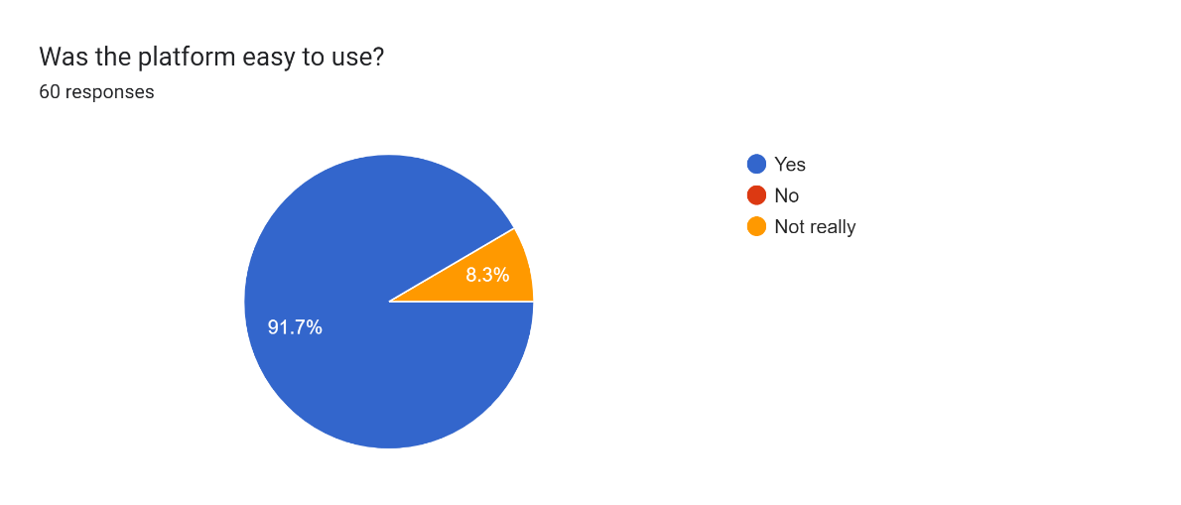

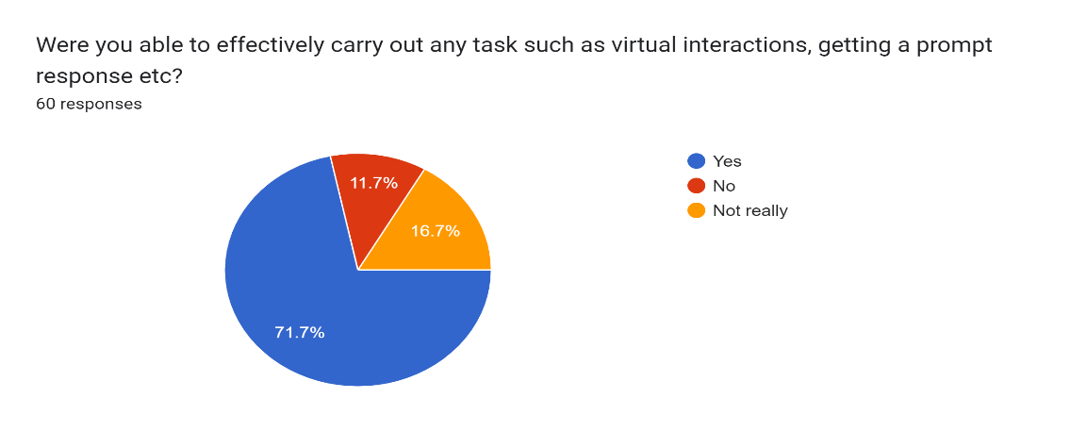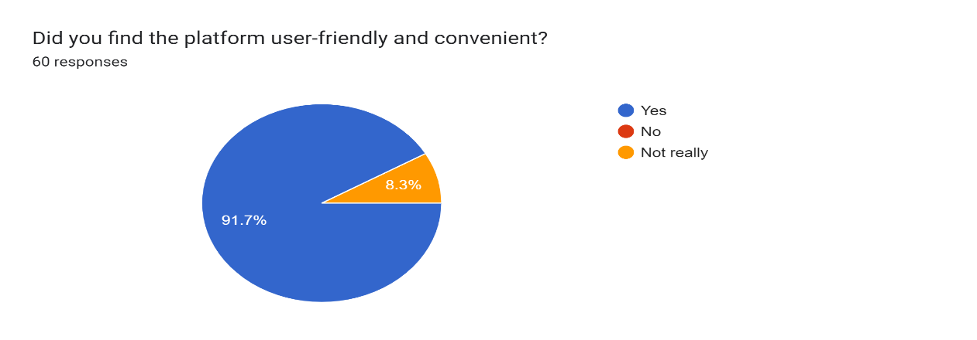

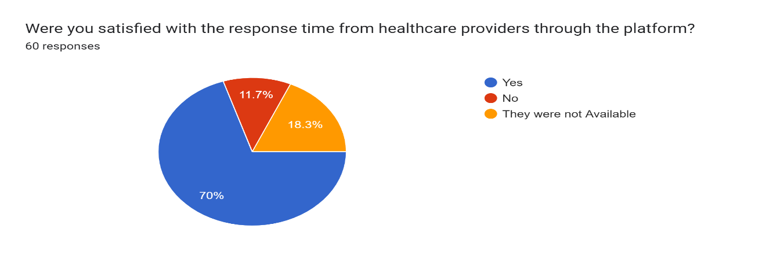

Forms response chart. Question title: Was it difficult learning how to use the platform?
1- Very difficult; 2- Difficult  3- Neutral; 4- Easy; 5- Very easy
. Number of responses: 60 responses.

Forms response chart. Question title: On a scale of 1 to 10, how satisfied are you with this E-clinic platform?
1- Poorly satisfied; 2- Not satisfied  3- Neutral; 4-Satisfied; 5-Fully satisfied
. Number of responses: 60 responses.

Forms response chart. Question title: Do you agree that this is also an acceptable way to receive healthcare services?
1- strongly disagree; 2 - Disagree; 3- Neutral; 4-Agree; 5-Strongly agree. Number of responses: 60 responses.

Forms response chart. Question title: How likely are you to recommend VIMONET E-clinic to others seeking remote healthcare services?
1- Extremely unlikely; 2- Somewhat unlikely; 3-Neutral; 4- Somewhat likely; 5- Extremely likely.. Number of responses: 60 responses.Forms response chart. Question title: How would you describe your first impression of VIMONET e-clinic platform?
1- Very negative; 2- Negative  3- Neutral; 4- Positive; 5- Very positive
. Number of responses: 60 responses.

The analysis of this survey is classified into Navigation, Usage, and Response time.

Navigation**:**

1. 91.7% of the respondents found the VIMONET e-clinic website easy to navigate
2. 8.3% of the respondents didn’t find it easy neither did they find it difficult.

Usage**:**

1. 71.7% of the respondents were able to make use of the website for various health related tasks.
2. 16.7% of the respondents were not able to use the website maximally.
3. 11.7% of the respondents were not able to use the website to perform any task.

Response time**:**

1. 70% of the respondents were satisfied with the response time from the healthcare providers through the website.
2. 11.7% of the respondents were not satisfied with the response time from the healthcare providers through the website.
3. 16.3% of the respondents were said the healthcare providers were not available.

The survey results indicate that the VIMONET e-clinic website is generally user-friendly and easy to navigate. Improvement is needed in the availability of healthcare providers and enhancing the user experience to enable user’s effectively carryout tasks. Furthermore, the inclusion of more visuals and personalized features would enhance the overall user experience.

**CHAPTER FIVE**

**SUMMARY, CONCLUSION AND RECOMMENDATION**

**5.1 Introduction**

This chapter gives the summary, conclusion and recommendation of the project.

**5.2 Summary**

The evaluation of VIMONET E-clinic's covers accessibility and acceptability of the website. This research work assesses how accessible it is to its users especially users with disabilities. This evaluation was carried out using five online automated tools to assess how accessible the platform is to users with disabilities, while the acceptability evaluation was carried through an online questionnaire that was answered by sixty participants who gave feedbacks on the improvements of the website. Addressing these concerns will aid to improve user experience and align with best practices in web development.

**5.3 Conclusion**

In conclusion, the accessibility and acceptability evaluation of the VIMONET E-Clinic website has revealed critical insights into the strengths and weaknesses of its digital presence. The rigorous examination through various automated tools, encompassing WAVE, Achecker, Lighthouse, TAW, and GTmetrix, has provided a nuanced understanding of the website's performance in terms of accessibility standards and user acceptability.

The identified issues, ranging from missing form labels and empty links to concerns about contrast ratios and semantic elements, underscore the importance of addressing accessibility challenges to ensure an inclusive user experience. The evaluation tools have not only pinpointed specific problems but also offered valuable recommendations for improvement, spanning from enhancing button semantics to optimizing page load performance. This project serves as a foundation for ongoing efforts to create a digital environment that is not only technically robust but also inclusive and user-friendly, ensuring that all individuals, regardless of abilities or disabilities, can seamlessly access and interact with the online platform.

**5.4 Recommendation**

Based on this research, the following recommendations are proposed towards creating a digital platform that is not only technically robust but also inclusive, with compliance to accessibility standards, which are:

1. Ensure that all form elements have clear and descriptive labels enhances accessibility for users relying on screen readers and other assistive technologies.
2. Improve the alt text for images throughout the website in order to convey the intended information of the image to assist users with visual impairments in understanding the content.
3. Ensure that buttons have accessible and discernible names.
4. Conduct regular accessibility audits:
5. Provide user training and awareness.
6. Web design should be improved continuously to meet with latest technologies.

**REFERENCES**

Adetunji, C. O., Olaniyan, O. T., Adeyomoye, O., Dare, A., Adeniyi, M. J., Alex, E., Rebezov, M., Garipova, L., & Shariati, M. A. (2021). eHealth, mHealth, and Telemedicine for COVID-19 Pandemic. *Assessing COVID-19 and Other Pandemics and Epidemics Using Computational Modelling and Data Analysis*, 157–168. https://doi.org/10.1007/978-3-030-79753-9_10

Alenoghena, C. O., Ohize, H. O., Adejo, A. O., Onumanyi, A. J., Ohihoin, E. E., Balarabe, A. I., Okoh, S. A., Kolo, E., & Alenoghena, B. (2023). Telemedicine: A Survey of Telecommunication Technologies, Developments, and Challenges. *Journal of Sensor and Actuator Networks 2023, Vol. 12, Page 20*, *12*(2), 20. https://doi.org/10.3390/JSAN12020020

Angood, P. B. (2001). Telemedicine, the Internet, and world wide web: Overview, current status, and relevance to surgeons. *World Journal of Surgery*, *25*(11), 1449–1457. https://doi.org/10.1007/S00268-001-0130-4

Angood, P., surgery, M.-W. journal. (2001). Telemedicine, the Internet, and world wide web: overview, current status, and relevance to surgeons. *Springer*. https://link.springer.com/article/10.1007/s00268-001-0130-4

Bashshur, R. L., Reardon, T. G., & Shannon, G. W. (2000). Telemedicine: A new health care delivery system. *Annual Review of Public Health*, *21*, 613–637. https://doi.org/10.1146/ANNUREV.PUBLHEALTH.21.1.613

Biancuzzi, H., Dal Mas, F., Bidoli, C., Pegoraro, V., Zantedeschi, M., Negro, P. A., Campostrini, S., & Cobianchi, L. (2023). Economic and Performance Evaluation of E-Health before and after the Pandemic Era: A Literature Review and Future Perspectives. *International Journal of Environmental Research and Public Health*, *20*(5). https://doi.org/10.3390/IJERPH20054038

Bisu, A., Gallant, A., Sun, H., … K. B.-2018 I. region 10. (2018). Telemedicine via satellite: improving access to healthcare for remote rural communities in Africa. *Ieeexplore.Ieee.Org*. https://ieeexplore.ieee.org/abstract/document/8629855/

Bokolo Anthony Jnr. (2020). Use of telemedicine and virtual care for remote treatment in response to COVID-19 pandemic. *J Med Syst*, *44*(7). https://doi.org/10.1007/s10916-020-01596-5

Bunnell, B., Barrera, J., Paige, S., … D. T.-I. journal. (2020). Acceptability of telemedicine features to promote its uptake in practice: a survey of community telemental health providers. *Mdpi.Com*. https://doi.org/10.3390/ijerph17228525

Chau, P., management, P. H.-I. (2002). Investigating healthcare professionals’ decisions to accept telemedicine technology: an empirical test of competing theories. *Elsevier*. https://www.sciencedirect.com/science/article/pii/S0378720601000982

Craig, J., & Patterson, V. (2017). Introduction to the practice of telemedicine. *Introduction to Telemedicine: Second Edition*, 3–14. https://doi.org/10.1177/1357633X0501100102

diseases, M. M.-P. in cardiovascular. (2013). Telemedicine and advances in urban and rural healthcare delivery in Africa. *Elsevier*. https://www.sciencedirect.com/science/article/pii/S0033062013001795

Everard, K. M., Schiel, K. S., Xu, E., & Kulshreshtha, A. (2022). Use of Telemedicine in the Family Medicine Clerkship: A CERA Study. *PRiMER*, *6*. https://doi.org/10.22454/PRIMER.2022.105712

Fouad, A. A., Osman, M. A., Abdelmonaem, Y. M. M., & Karim, N. A. H. A. (2023). Awareness, knowledge, attitude, and skills of telemedicine among mental healthcare providers. *Middle East Current Psychiatry*, *30*(1). https://doi.org/10.1186/S43045-022-00272-3

Goel, N., Alam, A., … E. E.-2017 39th A. (2017). Design and development of a customizable telemedicine platform for improving access to healthcare for underserved populations. *Ieeexplore.Ieee.Org*. https://ieeexplore.ieee.org/abstract/document/8037404/

Haleem, A., Javaid, M., Singh, R., international, R. S.-S. (2021). Telemedicine for healthcare: Capabilities, features, barriers, and applications. *Elsevier*. https://www.sciencedirect.com/science/article/pii/S2666351121000383

Jauregui-Velarde, R., & Andrade-Arenas, L. (2023). *Mobile App Prototype: Telemedicine for Mental Health Care During Pandemic*. https://repositorio.uwiener.edu.pe/handle/20.500.13053/8115

Kyriacou, E., … S. P.-B. (2003). Multi-purpose HealthCare Telemedicine Systems with mobile communication link support. *Biomedical-Engineering-Online …*. https://biomedical-engineering-online.biomedcentral.com/articles/10.1186/1475-925x-2-7

Lo, O., Fan, L., Buchanan, W. J., & Thuemmler, C. (2013). Conducting performance evaluation of an e-health platform. *Information Systems and Technology for Organizations in a Networked Society*, 295–315. https://doi.org/10.4018/978-1-4666-4062-7.CH016

Loane, M., & Wootton, R. (2002). A review of guidelines and standards for telemedicine. *Journal of Telemedicine and Telecare*, *8*(2), 63–71. https://doi.org/10.1258/1357633021937479

Lukas, H., Xu, C., Yu, Y., & Gao, W. (2020). Emerging telemedicine tools for remote covid-19 diagnosis, monitoring, and management. *ACS Nano*, *14*(12), 16180–16193. https://doi.org/10.1021/ACSNANO.0C08494

management, O. A.-I. journal of I. (2004). An internet-based telemedicine system in Nigeria. *Elsevier*. https://www.sciencedirect.com/science/article/pii/S0268401203001373

Mbunge, E., Muchemwa, B., International, J. B.-S. (2022). Are we there yet? Unbundling the potential adoption and integration of telemedicine to improve virtual healthcare services in African health systems. *Elsevier*. https://www.sciencedirect.com/science/article/pii/S2666351121000735

Miller, E. A. (2003). The technical and interpersonal aspects of telemedicine: Effects on doctor-patient communication. *Journal of Telemedicine and Telecare*, *9*(1), 1–7. https://doi.org/10.1258/135763303321159611

Mun, S. K., & Turner, J. W. (1999). Telemedicine: Emerging e-medicine. *Annual Review of Biomedical Engineering*, *1*, 589–610. https://doi.org/10.1146/ANNUREV.BIOENG.1.1.589

Patel, T., Johnston, C., … V. C.-I. journal. (2020). Utilizing telemedicine for group visit provider encounters: A feasibility and acceptability study. *Ncbi.Nlm.Nih.Gov*. https://www.ncbi.nlm.nih.gov/pmc/articles/PMC7514109/

Puentes, J., Puentes, J., Bali, R. K., Wickramasinghe, N., & Naguib, R. N. G. (2007). Telemedicine trends and challenges: a technology management perspective. *International Journal of Biomedical Engineering and Technology*, *1*(1), 59–72. https://doi.org/10.1504/IJBET.2007.014137

Roca, R. Y., & McCarthy, R. J. (2019). Impact of Telemedicine on the Traditional Veterinarian-Client-Patient Relationship. *Topics in Companion Animal Medicine*, *37*, 100359. https://doi.org/10.1016/J.TCAM.2019.100359

Sageena, G., Sharma, M., Engineers, A. K.-J. of T. I. (2021). Evolution of smart healthcare: Telemedicine during COVID-19 pandemic. *Springer*. https://link.springer.com/article/10.1007/s40031-021-00568-8

Shinoda, M., Hataji, O., Miura, M., Kinoshita, M., Mizoo, A., Tobino, K., Soutome, T., Nishi, T., Ishii, T., Miller, B. E., Tal-Singer, R., Tomlinson, R., Matsuki, T., Jones, P. W., & Shibata, Y. (2022a). A Telemedicine Approach for Monitoring COPD: A Prospective Feasibility and Acceptability Cohort Study. *International Journal of COPD*, *17*, 2931–2944. https://doi.org/10.2147/COPD.S375049

Shinoda, M., Hataji, O., Miura, M., Kinoshita, M., Mizoo, A., Tobino, K., Soutome, T., Nishi, T., Ishii, T., Miller, B. E., Tal-Singer, R., Tomlinson, R., Matsuki, T., Jones, P. W., & Shibata, Y. (2022b). A Telemedicine Approach for Monitoring COPD: A Prospective Feasibility and Acceptability Cohort Study. *International Journal of COPD*, *17*, 2931–2944. https://doi.org/10.2147/COPD.S375049

Sosa-Iudicissa, M., Wootton, R., & Ferrer-Roca, O. (1998). Chapter 1: History of telemedicine. *Studies in Health Technology and Informatics*, *54*, 1–17. https://doi.org/10.3233/978-1-60750-898-4-1

Vasquez-Cevallos, L. A., Iniesta, J. M., Gómez, E. J., & Hernando, M. E. (2018). Design and technical validation of a telemedicine service for rural healthcare in Ecuador. *Liebertpub.Com*. https://www.liebertpub.com/doi/abs/10.1089/tmj.2017.0130

Wilson, L., research, A. M.-H. informatics. (2015). Recent directions in telemedicine: review of trends in research and practice. *Synapse.Koreamed.Org*. https://synapse.koreamed.org/articles/1075753

**APPENDIX A**

**QUESTIONNAIRE ON ACCEPTABILITY EVALUATION OF VIMONET E-VLINIC WEBSITE**

Department of Computer Science

Federal University of Technology,

Minna.

December, 2023.

Dear Respondent,

I am an undergraduate student in the Department of Computer Science, School of Information and Communication Technology, Minna. I am working on a research project titled: Accessibility and Acceptability Evaluation of VIMONET E-clinic website.

This study is strictly an academic activity leading to award of Bachelor of Technology (B.Tech) Degree in Information and Communication Technology.

Please take a moment to fill the form, which will require you to visit the site and register your details. Your feedback is invaluable as we strive to enhance the user experience.

Yours’ faithfully,

Mercy Akintola.

VIMONET refers to a VItal sign MOnitoring NETwork system being developed after the COVID-19 pandemic in Nigeria by the team of researchers to be deployed for providing enhanced healthcare delivery services and management via telemedicine.

Click link to register and try to carry a task in order to carry out survey.[https://www.vimonet.health/]( %20https://www.vimonet.health/)

* 1. Email: _________________________
  2. Was the platform easy to use? __________________
  3. Did you find the platform user-friendly and convenient? _______________
  4. Were you able to effectively carry out any task such as virtual interactions, getting a prompt response etc? _____________________
  5. Were you satisfied with the response time from healthcare providers through the platform?
  6. Was it difficult learning how to use the platform?
  7. How would you describe your first impression of VIMONET e-clinic platform?
  8. On a scale of 1 to 10, how satisfied are you with this E-clinic platform?
  9. Do you agree that this is also an acceptable way to receive healthcare services?
  10. How likely are you to recommend VIMONET E-clinic to others seeking remote healthcare services?
  11. What specific features would you suggest to be added to the platform to enhance your overall satisfaction.

Thank you for taking your time to complete the questionnaire. Your feedback is invaluable in refining and improving VIMONET E-clinic platform.